Objective
Design and implement an end-to-end solution to automatically interpret electrical drawings by detecting symbols, identifying connecting lines/wires, and generating a structured graph representation of the electrical network.
Task Description
Given a set of electrical drawing files (attached separately), build a pipeline that:
- Detects and identifies electrical symbols present in the drawing.
- Detects lines/wires and their connectivity between symbols.
- Determines relationships and connections among detected components.
- Generates a structured JSON output containing:
  - Symbol name/type
  - Bounding box or coordinates
  - Connected symbols/components
  - Connection details (where applicable)
  - Any additional metadata deemed useful for graph generation
- Creates a graph representation of the electrical circuit/network using the extracted information.
Technical Expectations
- You are free to use any combination of:
  - Vision Language Models (VLMs)
  - Large Language Models (LLMs)
  - Traditional computer vision techniques
  - Machine learning or deep learning approaches
- However, you must develop the end-to-end pipeline, including:
  - Pre-processing logic
  - Symbol and line detection strategy
  - Connectivity inference
  - Post-processing and validation
  - JSON generation
  - Graph construction
- The focus is not only on achieving good performance but also on demonstrating sound engineering and architectural decisions.
Expected Deliverables
1. Solution Implementation
A working pipeline capable of processing the provided electrical drawings and generating the required outputs.
2. JSON Output
An intermediate structured representation similar to the example below:
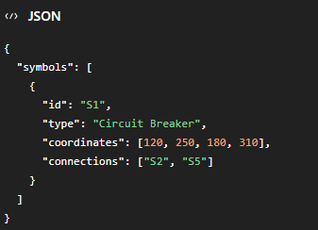
3. Graph Representation
A graph describing the components and their interconnections.
4. Technical Documentation
A concise document or presentation covering:
- Overall architecture
- Model selection rationale
- Pre-processing and post-processing logic
- Connectivity extraction approach

Evaluation Criteria
Candidates will be evaluated on:
- Quality and robustness of the end-to-end pipeline
- Design and implementation choices
- Scalability and maintainability of the solution
- Ability to justify architectural decisions
- Limitations and future improvements
- Accuracy of symbol detection and classification => Not the highest priority but scores higher if a generic scalable approach is implemented
- Correctness of connectivity extraction => Not the highest priority but scores higher if a generic scalable approach is implemented
Important Note
You must be able to clearly explain:
- Why a particular VLM, LLM, model, or framework was selected.
- Why specific pre-processing and post-processing techniques were used.
- The trade-offs considered during implementation.
- How the chosen approach contributes to achieving the desired performance, accuracy, and robustness.

